Superstore Sales Analysis using MYSQL
Tools: MYSQL workbench.
Dataset: Superstore Dataset.
Objective: Analyse sales, profit, customer segments, categories, states, and cities using SQL queries to derive business insights. Analyse sales, profit, customer segments, categories, states, and cities using SQL queries to derive business insights.
Dataset Information:
- Dataset: Sample Superstore
- Records: 9,994
- Tool: MySQL Workbench
Key Findings:
- Total Sales.
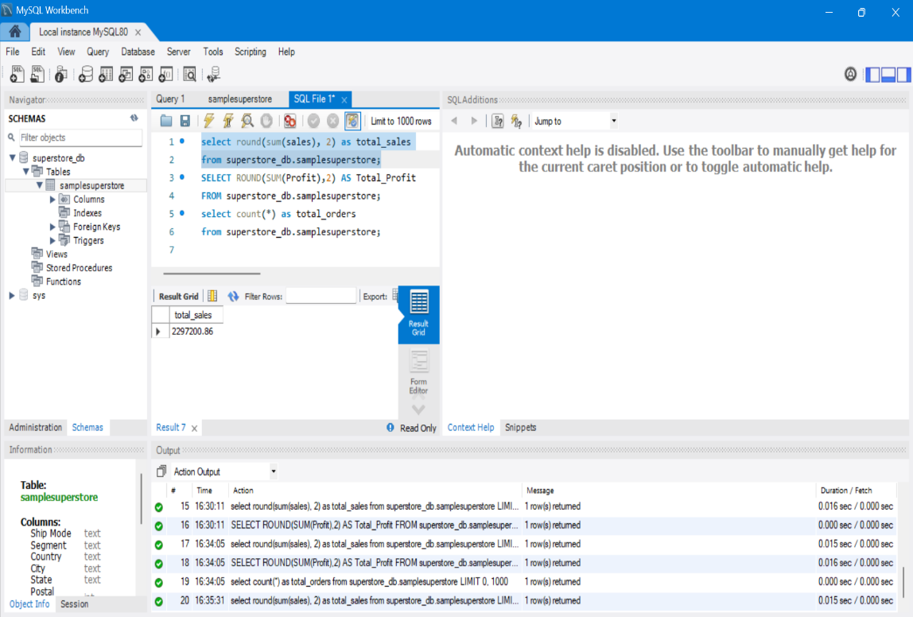
Insight: The company generated almost 2.3 millions in sales.
- Total Profit

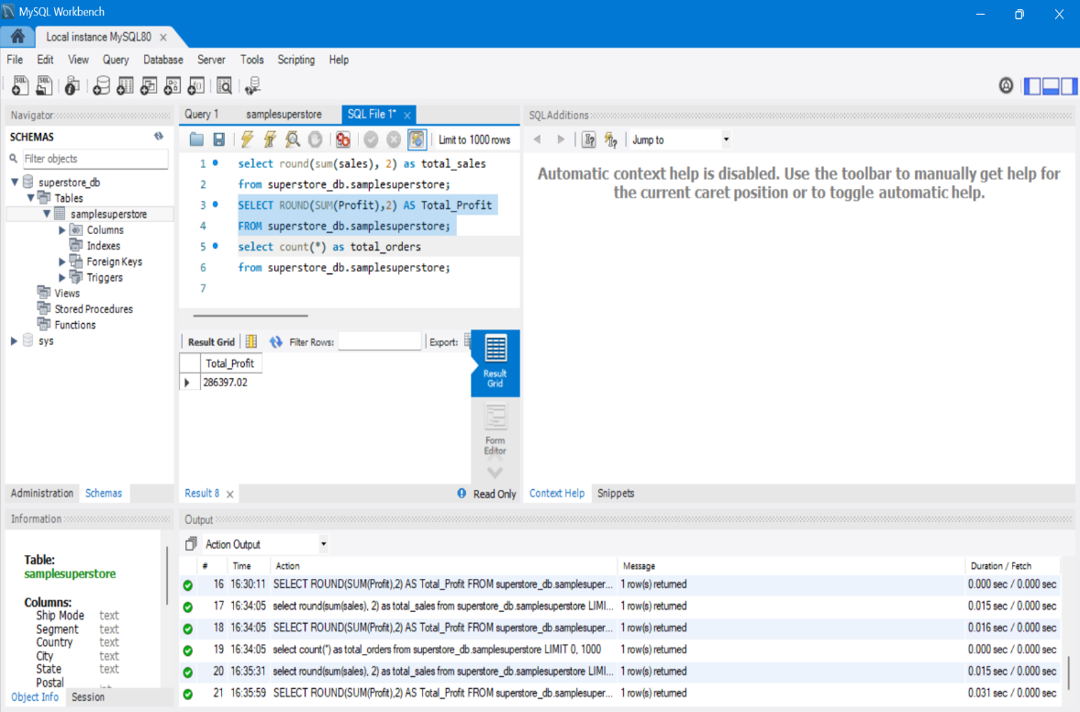
Insight: The company generated a total profit of 286,397.02

- Total Orders.

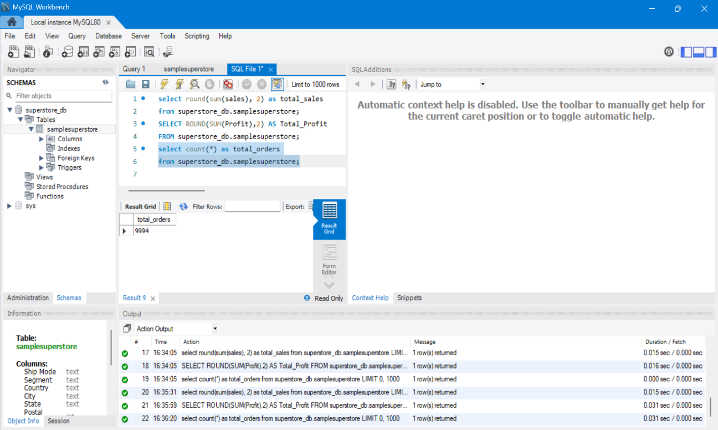
Insight: The company processed 9,994 orders.
- Technology generated highest sales.
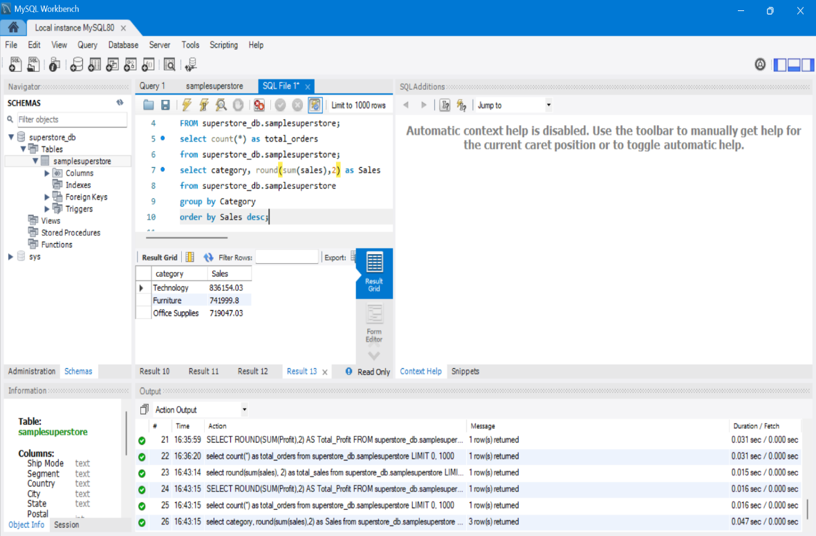
Insight: Among furniture and Office supplies technology category has generated highest sales.

- Technology generated highest profits
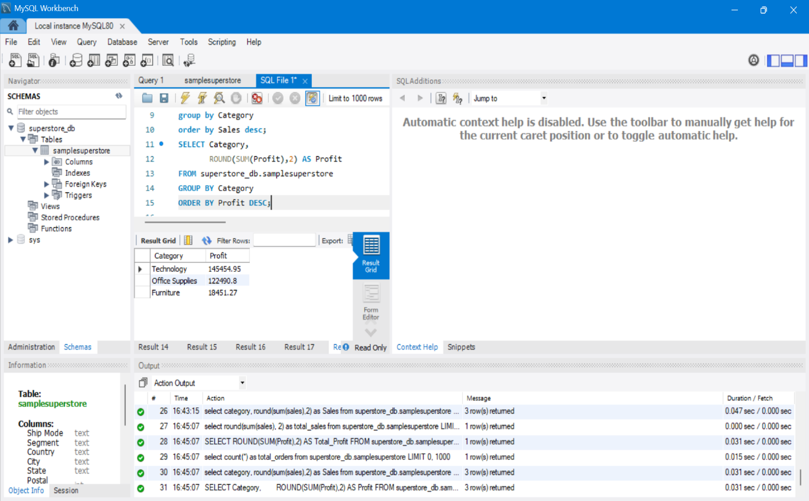
Insight: Among furniture and Office supplies technology is the only category with highest profit as well.

- State with highest sales.
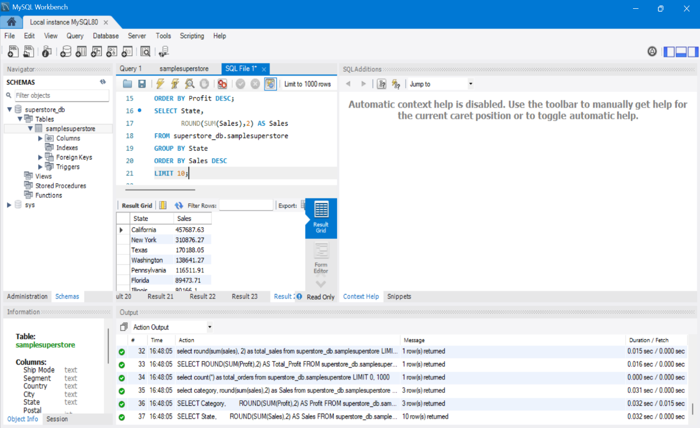
Insight: California is the state with highest sales.

- State with highest profit.
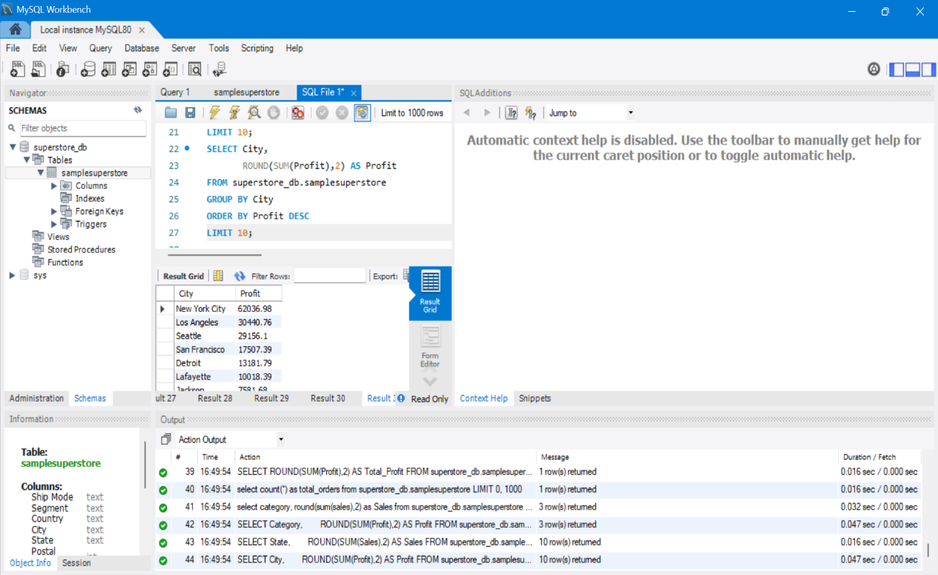
Insight: New York city has higher profit among other cities.

- Segment with highest sales.
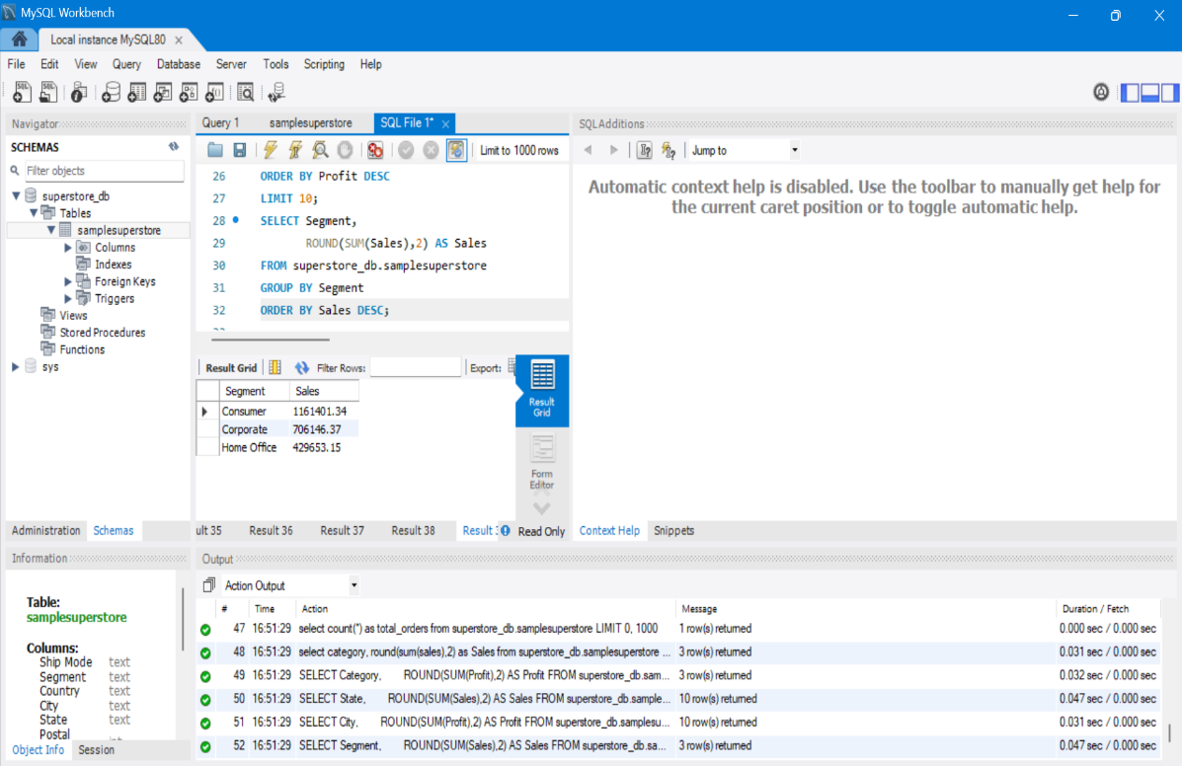
Insight: Consumer segment has highest sales compared to other segments.

Conclusion:
Using MySQL, sales and profit data from the Superstore dataset were analysed. The project identified top-performing categories, customer segments, states, and cities. SQL concepts such as SELECT, SUM(), COUNT(), GROUP BY, ORDER BY, and LIMIT were used to generate business insights and support data-driven decision making.

